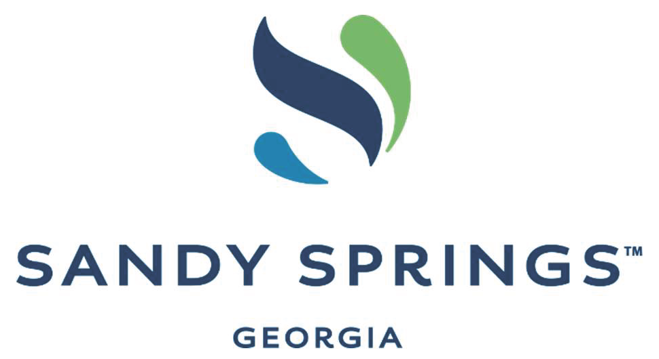
Sandy Springs Diversity and Inclusion Task Force:
Housing Subcommittee Presentation of Recommendations

THE CITY’S EXISTING WORKFORCE HOUSING INITIATIVES:

- CDBG FUNDING: Reallocate funds from Community Development Block Grant Funding to support workforce housing initiatives when the city’s current Section 108 loan for sidewalk projects finishes. Anticipated date of initiative: 2024
- HOUSING INCENTIVE POLICY: Revisit the Economic Development Incentive Policy for Affordable Housing. Since its creation in 2017, no developer of the North End has taken advantage of these incentives. Anticipated date of initiative: late 2021

TASK FORCE RECOMMENDATIONS:
- Invest in Expertise on and Transparency of Housing & Best Practices for Redevelopment
  - PHASE 2 HOUSING STUDY: Reinstate Phase 2 of the Housing Needs Assessment proposed in December 2020 but suspended by City Council in January 2021. This assessment will provide research-based recommendations of what other cities have done to tackle similarly complex housing obstacles.
    - Assistant City Manager Kristin Smith identified this study as a “strong first step” the city should take toward workforce housing.
    - This study should be carried out through HR&A, who completed Phase 1 of the Housing Needs Assessment. Reasons include
      - Consistency with previous steps to understand the city’s challenges (Phase 1)
      - A breadth and depth of experience and knowledge of what other cities in the country are doing to meet this challenge
      - Alignment with the city’s approach and philosophy to hire outside consultants for expertise and ensuring a higher priority to address complex issues
      - Immediate inclusion of the Latinx community in the workforce housing conversation: HR&A has agreed to provide all past documents such as the Housing Needs Assessment and all future assessment documents in Spanish.
  - DIRECTOR OF HOUSING: create a position which is responsible for ensuring all redevelopment projects are evaluated and implemented through a racial equity lens and impact of diversity. Redevelopment includes trails, parks, commercial properties and residential housing, which all influence maintaining workforce housing for working families.
    - All housing development proposals considered should include a presentation of and public access to data regarding the sites impacted: location of the site, number of units impacted, and number of families making $50K or less who are/are not able to continue living in the new development.
- Increase the scope of incentives in the Economic Development Incentive Policy for Affordable Housing.
  - Expand the existing incentives beyond the North End
  - Lower tax rates to developers
  - Give height allowances to developers to allow them to build higher, creating
more density to increase their profits
  - In exchange for incentives, developers must
    - Provide at least 25% of units designated for workforce housing for renters earning $50K or less. Prices would be guaranteed for ten years. In the case of the city first purchasing property, this number should be increased to 30% of units designated for workforce housing.
    - Provide 3 BR units to ensure larger families are included in redevelopment plans
and not just individuals and small families.
    - Provide a right of first return for residents displaced due to demolition.
Note: The Phase 2 Housing Study, when reinstated, will provide additional options for how other
cities are partnering with developers in the goal of creating workforce housing.

- Preserve and Protect All Remaining NOAHs. In order to protect diversity on all levels, the city needs to take immediate steps to preserve the naturally occurring affordable housing (NOAH) the city is known for: older complexes.
  - Matthew Bedsole, Senior Analyst at HR&A Advisors, spoke of the importance of the city’s NOAHs at the November 3, 2020 City Council Meeting: “The one thing we found unique about Sandy Springs is the quantity of affordable housing that exists here today in the city which is different than the other municipalities around the northern arc...this is not just a resource that you can snap your fingers and build. It’s something you’re lucky enough to inherit.”
  - According to the Housing Needs Assessment, there are 13,510 multifamily housing units in need of preservation and protection.
  - Recommendation for buildings that house these units: For all renovation permits submitted to the city, approval must be contingent upon 30% of the units remaining affordable (for families making $50K) for twenty years. These units must be a mix of one, two, and three bedroom units.

“Workforce Housing” should be defined as households earning $50K or less and is terminology aligned with the city’s addendum to the Next Ten Comprehensive Plan, which states its priority actions are to “preserve quality, affordable, and workforce housing for teachers, first responders, healthcare workers, and others who are essential to the community.”

