# CURRENT CONSTRUCTION ACTIVITIES

## LAST WEEK - WEEK ENDING 03/15/2025

**3rd Floor:**

* Furniture Install
* Punch List Work

**2nd Floor:**

* RTCC Equipment & Furniture Install
* Punch List Work

**1st Floor:**

* Terminating data Cables at IT Closets
* Testing 1st Floor Data Cables
* Access Control Devices
* Teller Speakers & Glass
* Rubber Base
* Signage
* Furniture
* TV’s
* Touch Up Paint

**Basement:**

* Millwork
* Water Dinking Fountains
* Final Paint
* Flooring

**Exterior:**

* Planting
* Crack & Fill at Upper Lot

THIS WEEK – WEEK ENDING 03/22/2025

**3rd Floor:**

* Routing Data at Furniture
* Punch List Work

**2nd Floor:**

* Routing Data at Furniture
* Punch List Work

**1st Floor:**

* Terminating Data Cables at IT Closets
* Testing 1st Floor Data Cables
* Signage
* Audio Visual
* Furniture

**Basement:**

* Terminating Data Cables at IT Closets
* Millwork
* Final Paint
* Flooring
* Existing Elevator Inspection
* New Elevator Adjusting
* Furniture

**Exterior:**

* Crack & Fill at Upper Lot
* Pressure Washing Brick
* Fencing

# JOBSITE PHOTOS

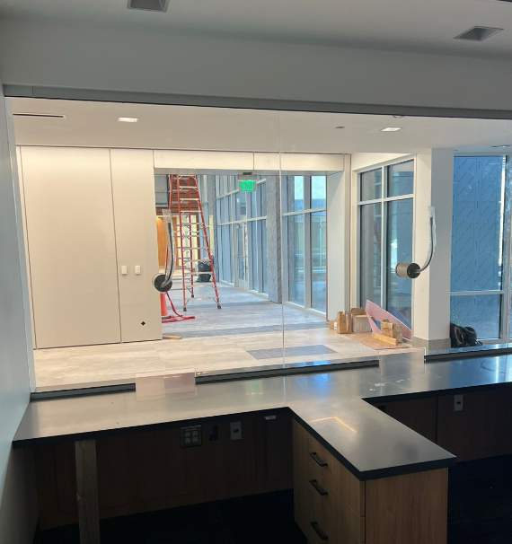

Service & Teller Windows

## 

## 

## 

## 

## 

## 

## 

Data Terminations at IT Closet

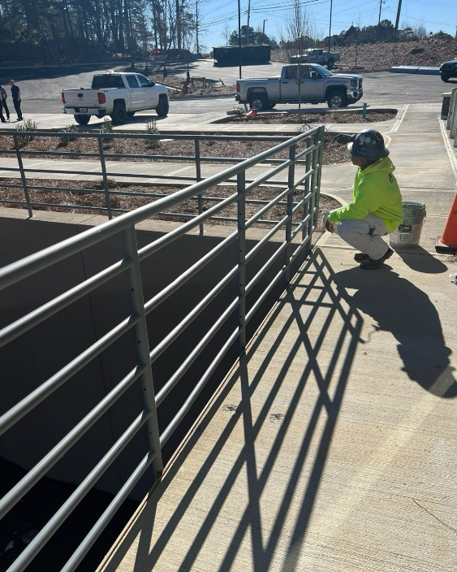

Painting Exterior Railings

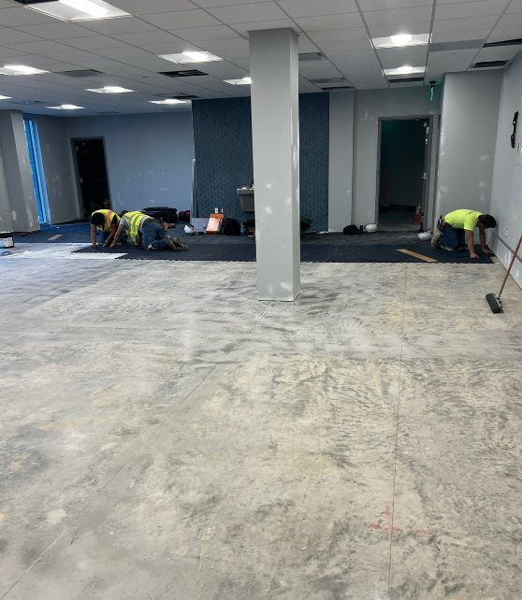

Floor Prep & Install at Gym

 WEATHER

### Weather delays this week: 0

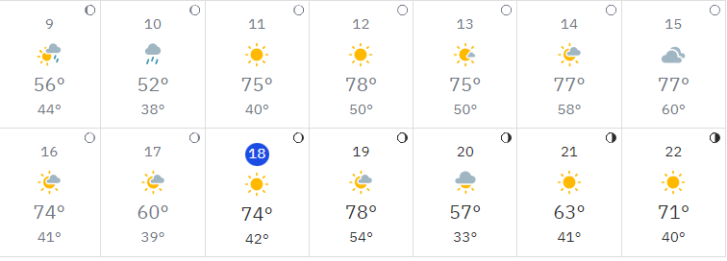

* Total Weather Delays: 55

 SAFETY REPORT

## Days without an accident: 410

* + Days without lost time: 410

MILESTONE TRACKING

* + - Construction Start: August 21, 2023
    - Current Contract Completion Date: Mar 14, 2025